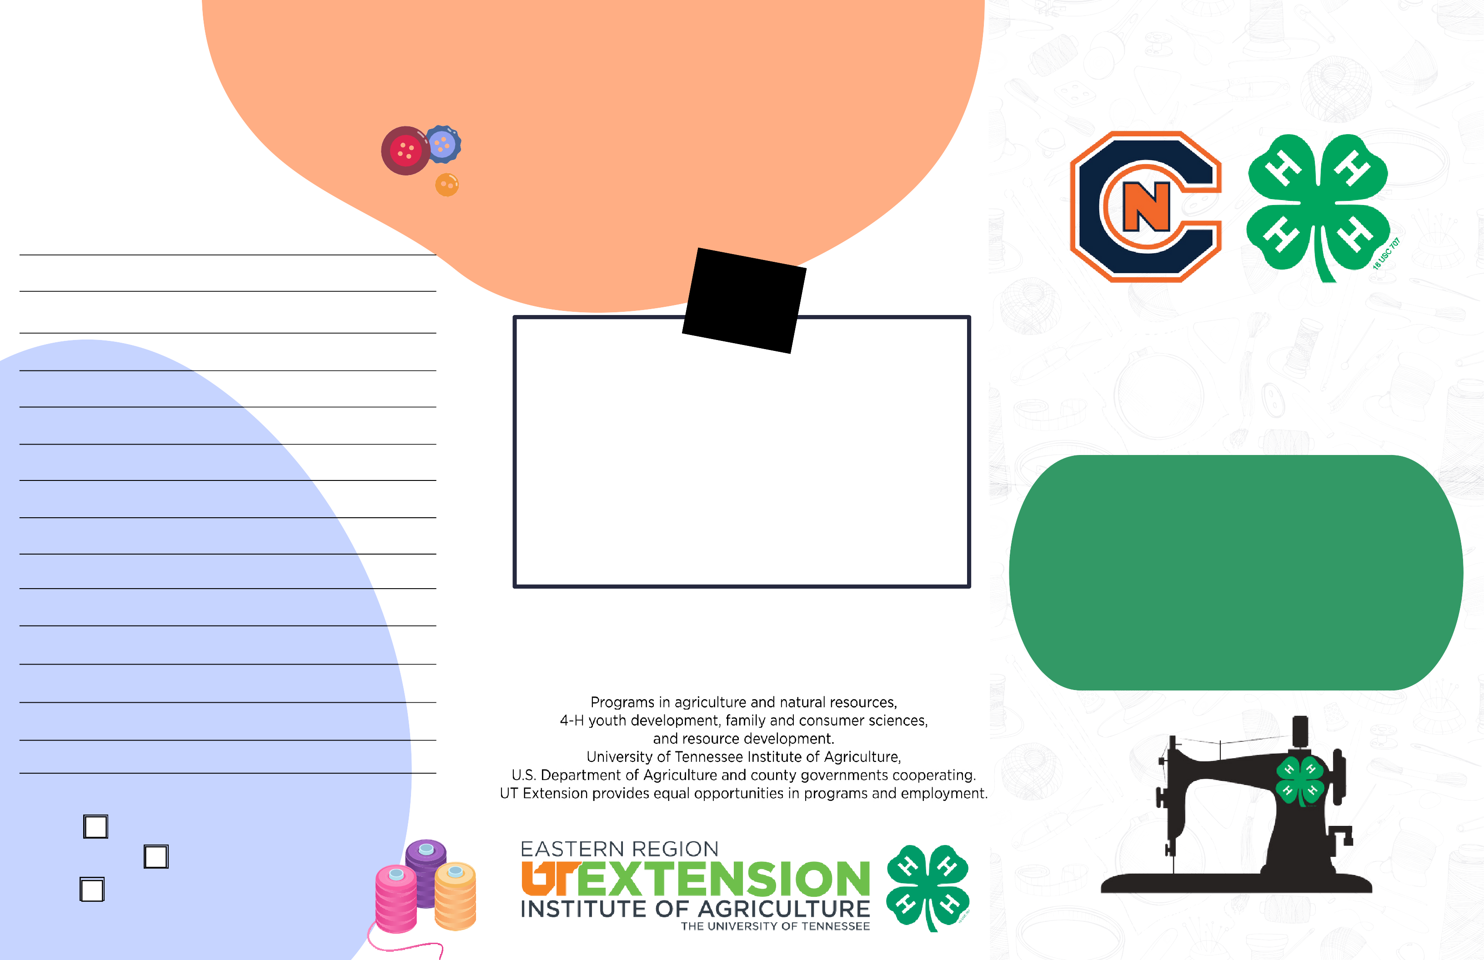
Registration:
Deadline to Eastern Region: April 1st, 2024 (County Deadline will vary)
Name:
Guardian Name: Female OR Male: Grade (Jan 2024): County:
Mailing Address:
City, State, Zip: Email:
Phone:
Roommate Preference:
Dietary/Health needs: Fashion Show (select one):
Sewn Purchased Both
Contact your county Extension Office to register!
E A S T E R N R E G I O N

FASHION AND DESIGN CONFERENCE
June 4th-6th, 2024
Carson Newman University
6th-12th Grade
(must have completed 6th grade)
$200

Country Tonite!
For your projects, lunches, traveling and more!
The Country Tonite
Show outing in Pigeon Forge!
Also meet with the Costume Designer and tour backstage!

Thrifting!
Thrift shopping at local thrift store and learn to take care of different clothing
pieces!

Tour Carson Newman University!
Tour the Family and Consumer Sciences building at Carson Newman University!

Work Shops and More:
Exciting new workshops like: Origami
Washer jewelry making Rocky Top coaster making Suminagashi
Delicious Culinary project for the parent reception!
Service project to exercise the 4-H Hands to Larger Service!
Connect & meet new friends during a night on the lawn with an ice cream social, line dancing and other fun activities
Clover Collection!
Fashion Show on the last day!

Sewing Project:
Japanese Knot Bag

